Feature Proposal for Flam AR App

Role: Product Management Intern

Candidate: Prudhvi Naidu Thota

Date: 26 – 05 - 2025

# Problem Statement

First-time users often struggle with the AR experience due to a lack of guidance and creative inspiration. Many abandon the app before realizing its full potential. There's also a gap in retaining users through unique, interactive features that encourage repeat usage.

**Objective**

To design and propose a new feature for the Flam AR app that:  
● Improves first-time user experience  
● Boosts user engagement and retention  
● Enables new and creative use cases  
● Addresses user pain points and gaps in the existing AR experience

**Problem Statement**

New users often struggle to understand how to navigate the AR app, leading to high drop-off rates. Meanwhile, experienced users may find a lack of evolving creative challenges, leading to declining engagement. There is a need to bridge the gap between onboarding and long-term engagement by providing intuitive, guided, and inspiring AR experiences.

**Proposed Feature: "AR Quest Mode"**

**AR Quest Mode** is an interactive, gamified feature that offers a guided journey for users, particularly beneficial for first-time users. It consists of a series of creative AR challenges or tasks—ranging from simple actions like placing an object to more complex storytelling tasks. Each quest is tailored to teach users how to use features of the app while sparking creativity and rewarding engagement.

**Key Elements of AR Quest Mode**

* **Guided Onboarding Quests**: Interactive tutorials with rewards (badges, filters, etc.)
* **Daily/Weekly Creative Quests**: New themed challenges (e.g., “Teleport to a Fantasy World”)
* **Community Voting**: Users vote on the best quest submissions
* **Progress Tracker**: Gamification through levels and achievements

**User Flow**

1. User signs up and is welcomed with the option to start "AR Quest Mode"
2. First quest introduces camera, object placement, and simple interactions
3. On completion, user earns a badge and unlocks the next challenge
4. Users can revisit, share, or skip quests
5. Progress is shown in a visually appealing dashboard

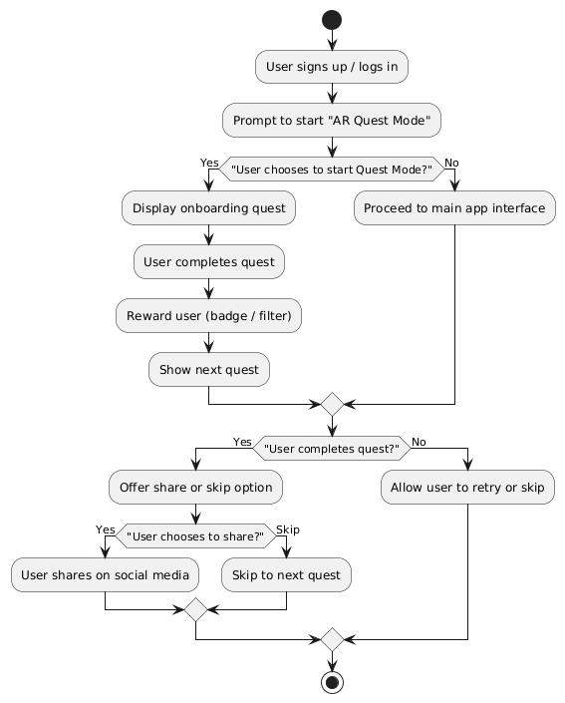

**Benefits & Impact**

* **Improves First-Time Experience**: Users learn by doing, rather than watching static tutorials
* **Boosts Engagement & Retention**: Fresh quests keep users coming back
* **Enables Creativity**: Prompts encourage storytelling, roleplay, and imagination
* **Solves Pain Points**: Reduces drop-offs, demystifies features, and motivates continued exploration

**Hypothetical Metrics**

* Onboarding Completion Rate: +30%
* Weekly Active Users (WAU): +20%
* Feature Adoption Rate: +25%
* Retention Rate (Day 7): +18%

**Future Scope**

* **User-Created Quests**: Let creators design and share their own quests
* **Collaboration Mode**: Group quests where friends can co-create scenes
* **Brand Tie-ins**: Quests featuring branded content, events, or sponsorships

**Conclusion**

"AR Quest Mode" transforms the user journey from passive exploration into an engaging, rewarding adventure. By combining learning with creativity and gamification, Flam can better onboard, entertain, and retain its growing AR community.